Instruction how to send Rubles from **Sberbank** to NIIB

*Through mobile application of* **Sberbank**

1. Log in to Sberbank application by your pin, password or finger print.
2. Open the main page of the mobile application. At the very bottom, choose a payment section («Платежи»).

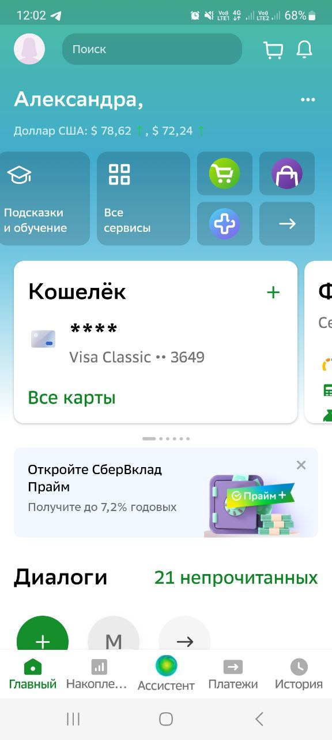

1. Choose the section Transfer (Перевести) and tap on the field Enter telephone, card, account (Введите телефон, карту, счет)

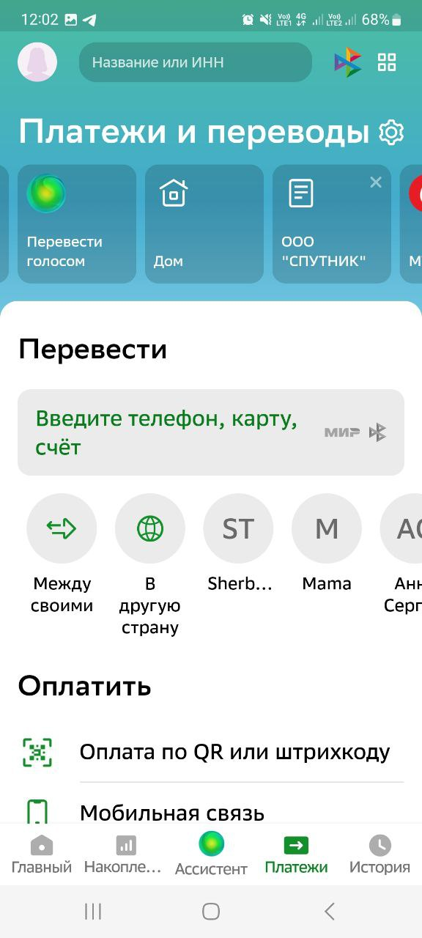

1. In the field By phone, card, number (По телефону, карте, счету) type your account number 40820810300010012000 as shown below

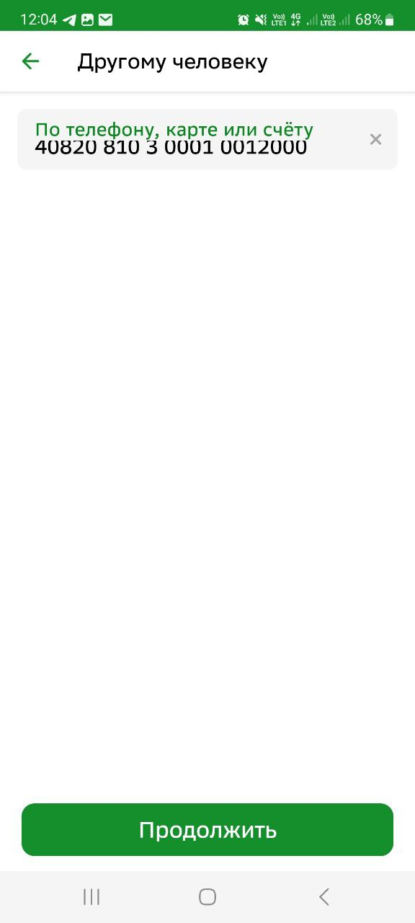

1. Fill in the fields as shown below:

* your family name - Warnakulasooriya
* name - Sujith Dilshan Fernando
* BIC (БИК) - 044525413
* Purpose of payment – commission (комиссия)
* Amount – 1500 rubles

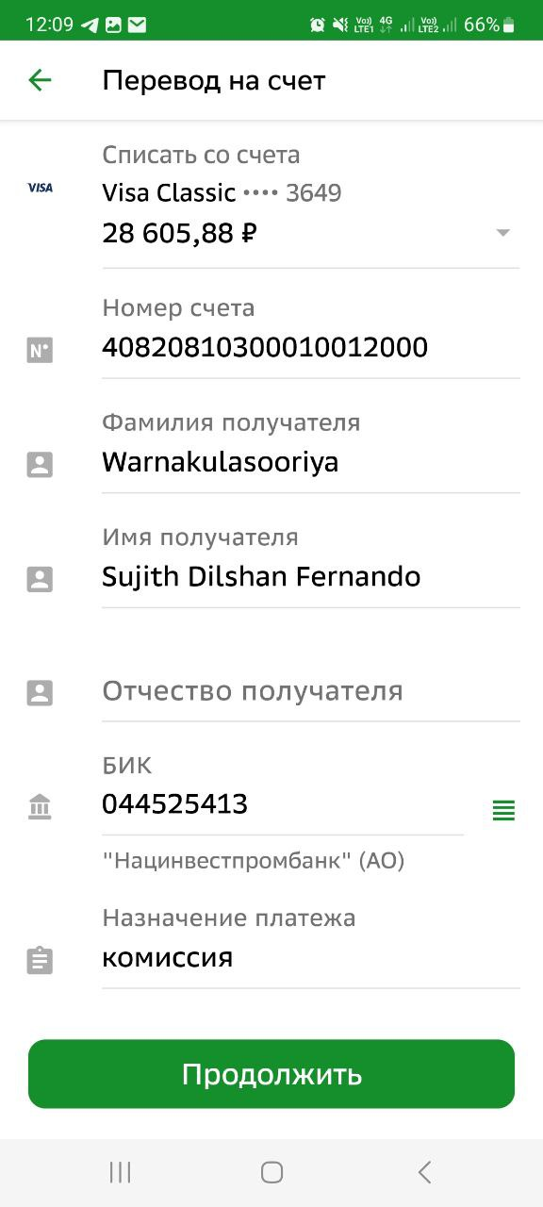

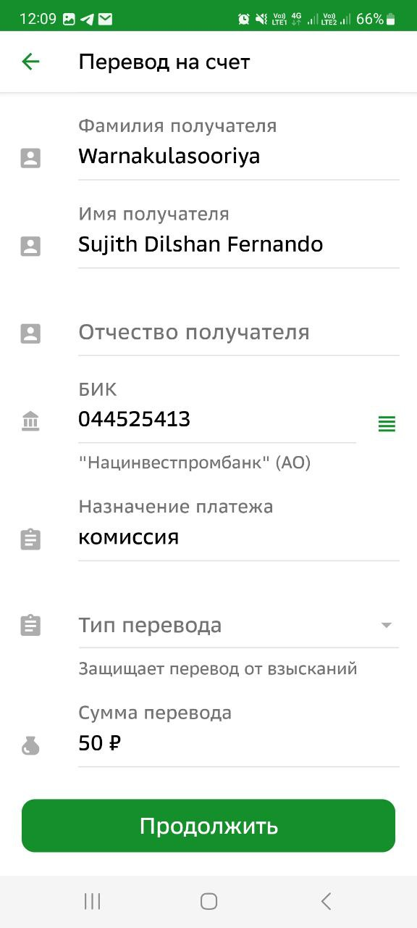

1500 P

1. Press Continue (Продолжить)